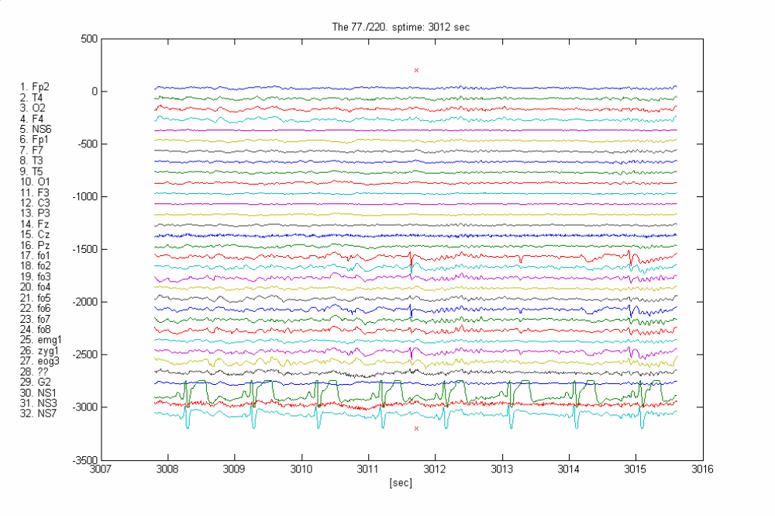
EEG

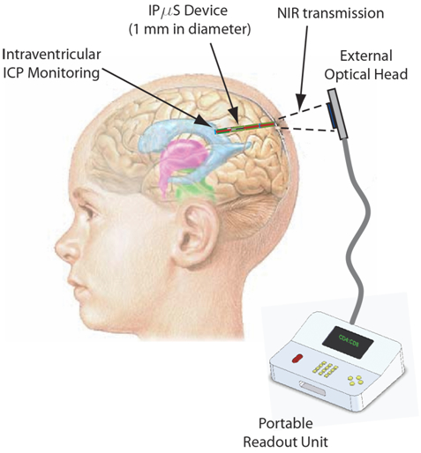
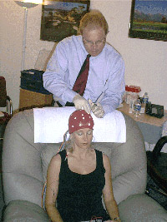

Intracranial Pressure (ICP) Monitoring
www-personal.umich.edu/~chronis/ICP.html
'An opto-fluidic sensor for monitoring intracranial pressure' Kodandaramaiah S.B. and Chronis N., 12th International Conference on Micro Total Analysis Systems (µTAS), San Diego, (2008).

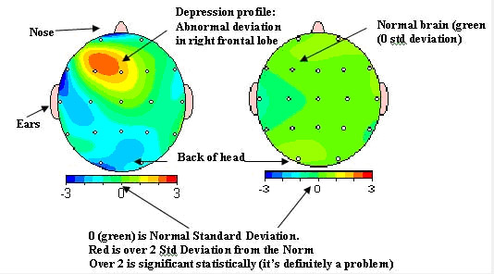

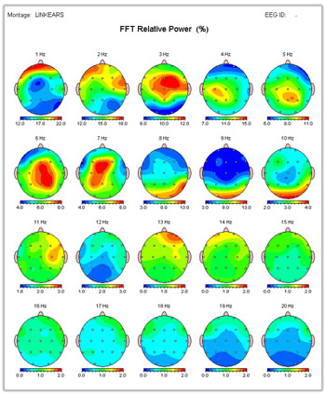

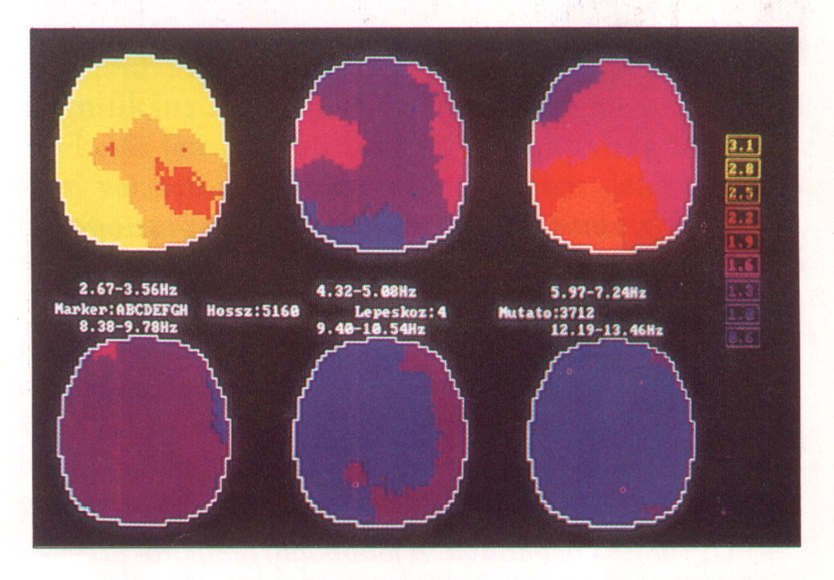

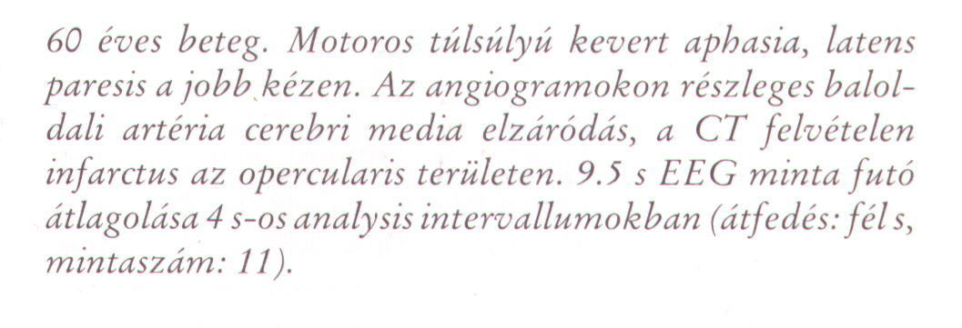

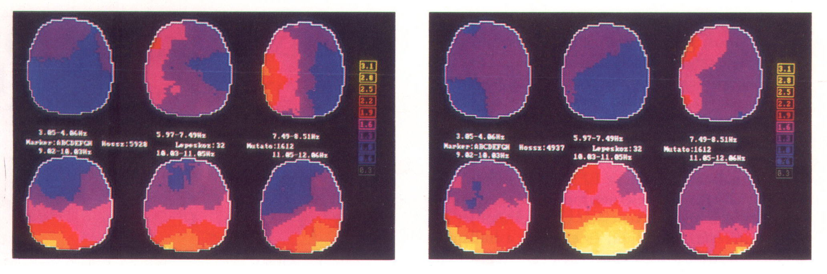

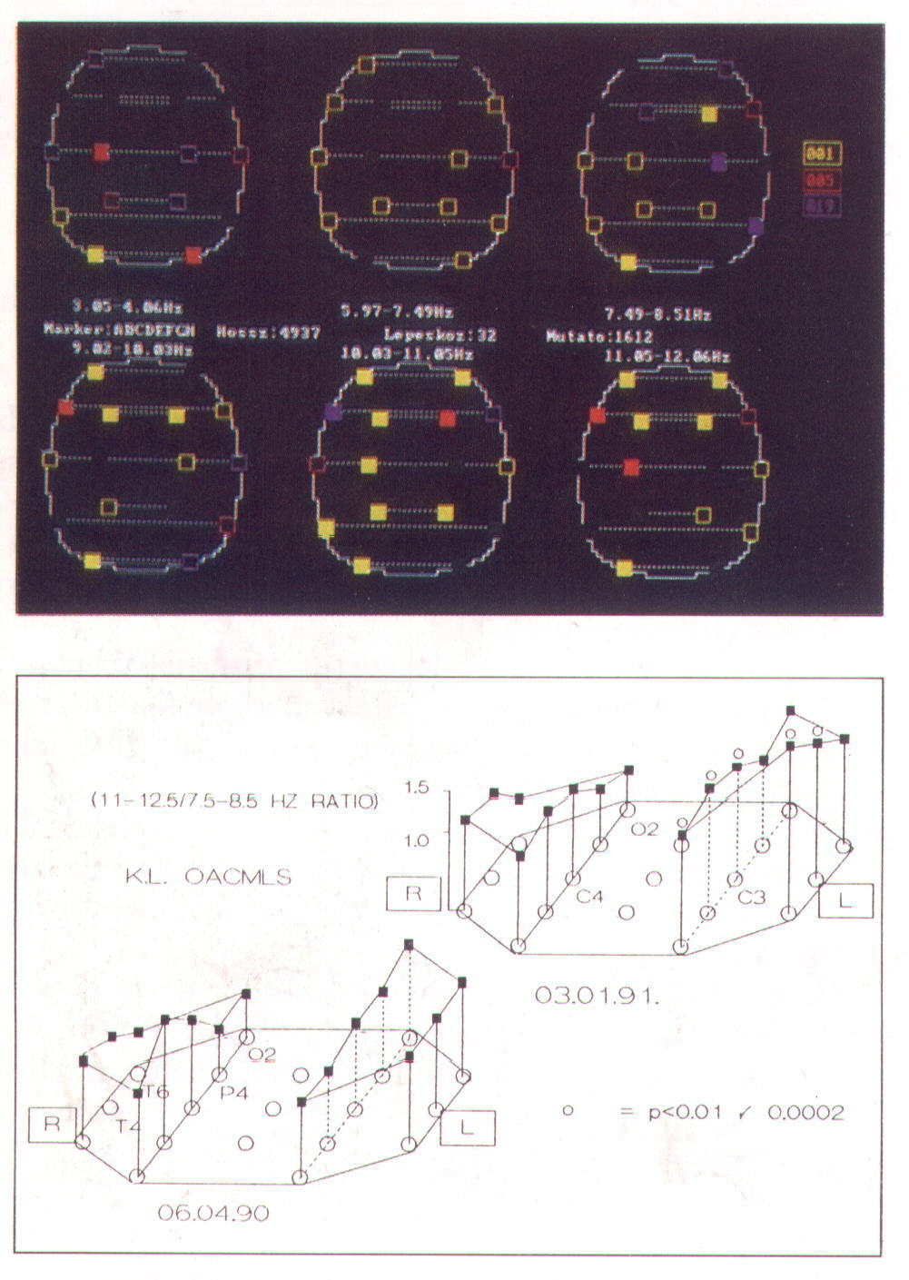

A korrelációs együtthatót ρ-val jelöljük és a következő képlettel számítjuk ki :
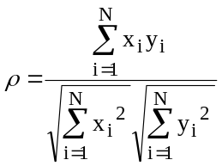
ahol x_{i} és y_{i} mutatja a sablont és az aktuális mintavett értékeket külön-külön.

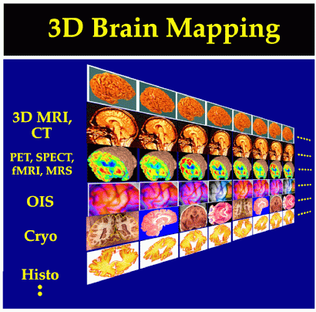

fMRI

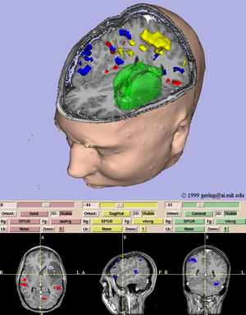

fiber

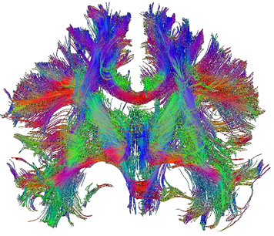

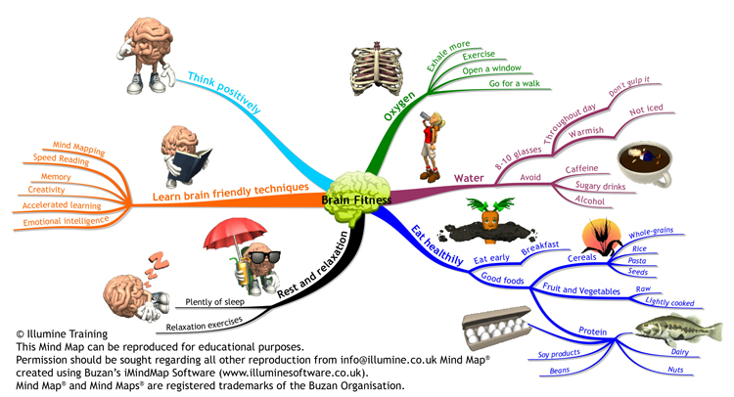

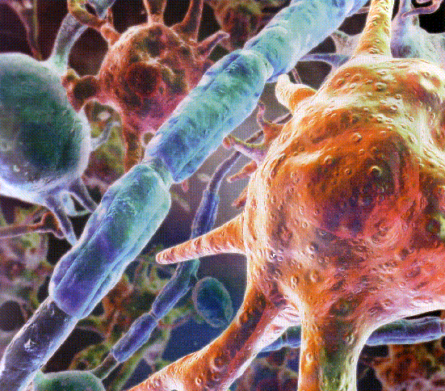

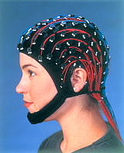
Finally, an elecrode positioning system with some serious thought behind it! Quik-Cap's highly elastic fabric provides a uniform fit over a wide range of head size and shape variability. Quik-Cap is available in five sizes with 32 to 256 channels. Sintered Ag/AgCl electrodes are recommended.

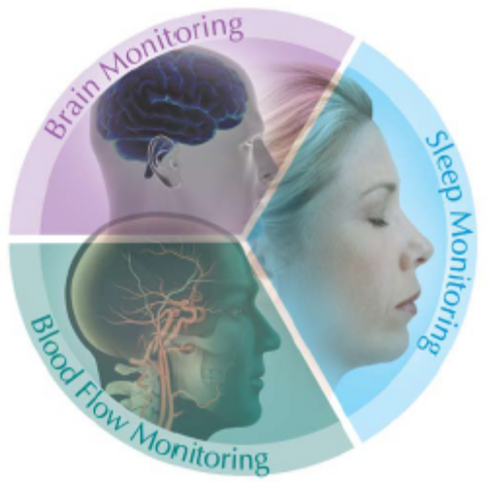
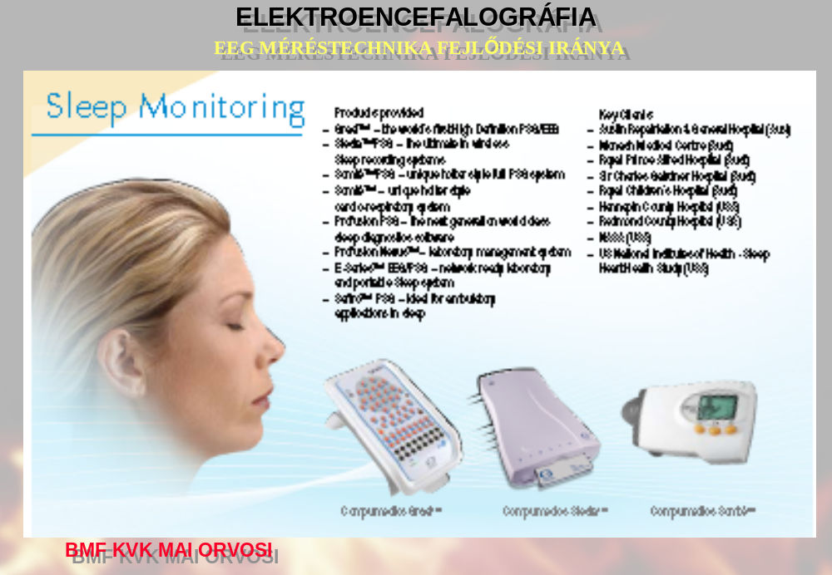

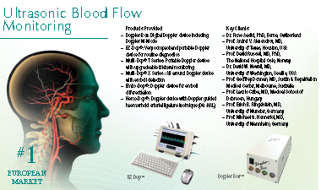

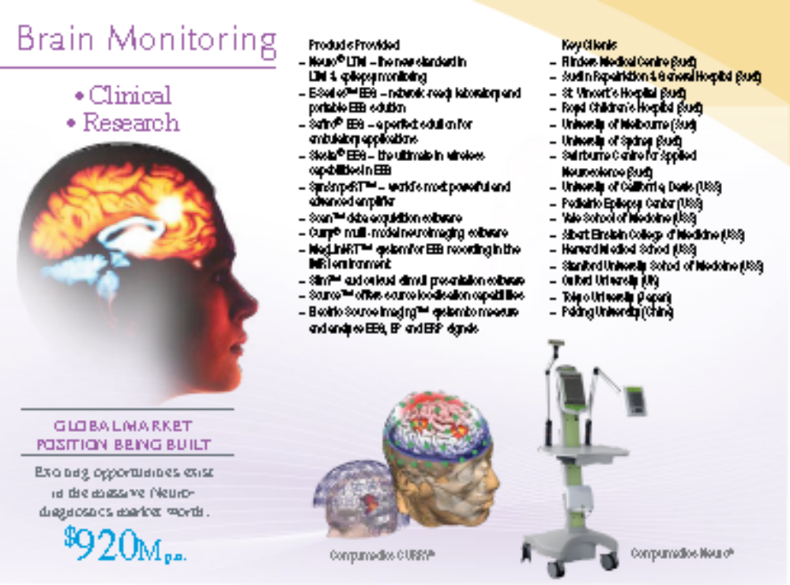
Polysomnography PSG


Clinical Diagnostic systems for sleep disorders
Visit
Clinical Diagnostic systems for neurophysiology
Visit

World-leading Research EEG/ERP systems
Visit Website

Transcranial Doppler (TCD) and associated Doppler technologies
Visit Website

Online catalogue for electrodes, sensor and supplies for Neurology and Sleep laboratories
Visit Website

Compumedics offers diagnostic systems for laboratory, ambulatory and portable applications. | 

  
  E-Series  Siesta  Somté PSG  Grael |  | Somté PSG  E-Series  Siesta  P-Series |  | Somté  Somté PSG
  
  E-Series  Siesta  Scan LT  SynAmps2 - Neuvo LTM EEG |  | E-Series |  | Siesta  Safiro
  
  Somté
  
  Software is the key to clinical system productivity. Our software products handle the clinical applications for PSG, EEG and cardiology, but also laboratory productivity concerns such as integrated database functions and network management.
  ProFusion PSG
  ProFusion EEG
  ProFusion neXus
  Scheduler for ProFusion neXus
  
  For clinicians to fully understand their patients conditions. Compumedics developed this sophisticated technology enabling high resolution video and audio applications for time-linked and real-time laboratory monitoring over the network.
  Digital Video for Sleep/PSG
  Digital Video for EEG Systems
  
  Innovation is the theme. Superior technology and rugged design have propelled these products to the forefront of the market. The sensors and accessories are used with Compumedics and other systems.
  Summit IP

http://www.neuroscan.com/research.cfm

MagLink RT
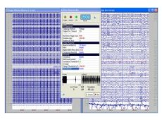
-
Curry
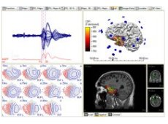
-

Scan
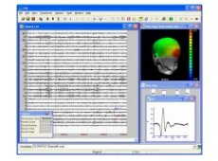
-

STIM²
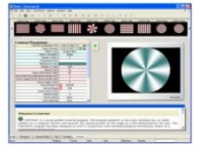
-

Access SDK
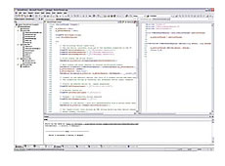
-

SynAmps RT
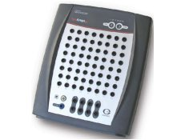
-

Scan NuAmps Express
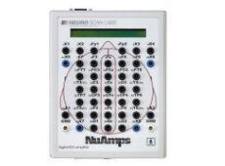
-

Source 5
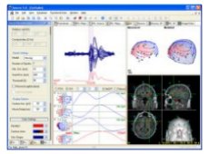
-

Quik-Caps
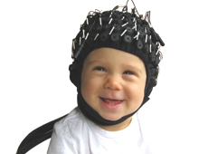
-

QuikCell
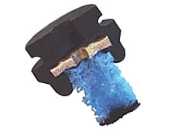
-

Source 2
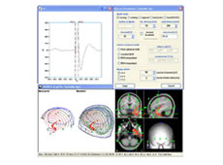
-

Epilepsy Platforms Brochure
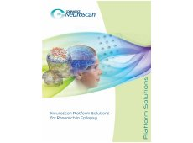

A JÖVŐ http://www.neuroscan.com/curry.cfm
CURRY 6
Multi-Modal Neuroimaging
CURRY 6 integrates multiple complementary functional and imagemodalities (EEG, ECoG, MEG; MRI, fMRI, PET, SPECT and CT) in a single software package for the purpose of obtaining the maximum accuracy of electrical source analysis. CURRY uses the full physical anatomy from MR and CT to provide three-dimensional models of the skull and brain allowing the neural generators of the topographic EEG to be computed. CURRY was developed for mapping and identification of the neural generators of EEG and MEG recordings. However, the functionality offered and the revolutionary changes in this latest version CURRY also make it suitable for wider application, including clinical applications in neurology, epilepsy and radiology.

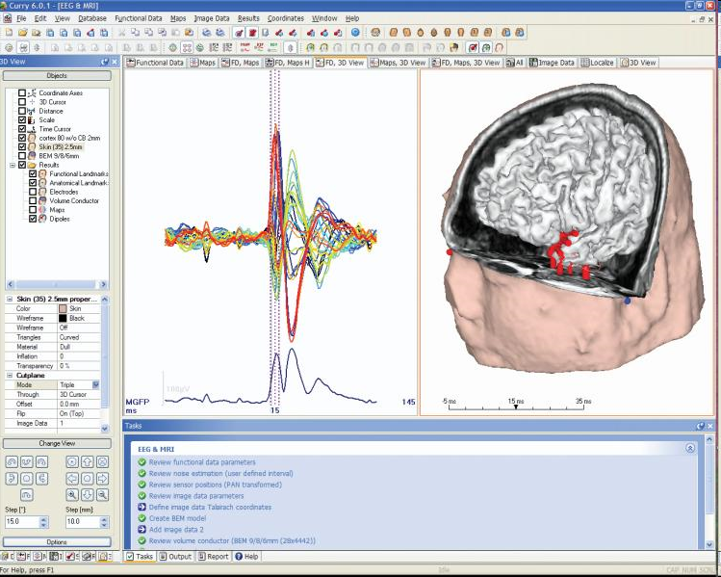

The micro-electrode array that we use to record signals from the brain is manufactured by Cyberkinetics, Inc. It is 4 mm across and contains 100 electrodes. The array is chronically implanted in the brain, and wired to a connector on the skull.
